# Aquantis Tow Tank Dynamic Rig Assembly Process and Checklist

## Final Assembly of Structure

Position 16.5 meter long segments across the channel. Check for excessive deflection and support at center as necessary.

Port (long) side (Drawing Item 1)



Starboard (short) Side (Drawing Item 2)



Slide long pieces such that there is an 11m gap between the segments.

Position forward (with track) and aft lateral assemblies (Drawing Item 3). Take care not to damage or bend track assembly.

Assembly the 4 connections with 4 double ended connectors, taper pins and safety pins. Coat connectors with moly-kote assembly paste.

Assemble track cars onto either side of track in this order. Electrical support car, mooring car, electrical support car, mooring car, electrical support car.

Assemble channel with track (Drawing Item 7 & 8) into the forward starboard corner. Take care not to damage or bend track assembly. Insert and tighten all missing bolts.

*Be sure to insert track alignment wedge between the two pieces of track.

Prepare 3 meter uprights for assembly. Drill (8) - 5/16” drain / fill holes per truss section approximately 6-8” from the ends into the 50mm tubes. See already drilled sections for reference.

Assemble (1) 3 meter truss section to each open T-junction in the base rectangle. Assembly the 4 connections with 4 double ended connectors, taper pins and safety pins. Coat connectors with moly-kote assembly paste.

Assemble corner supports, where best fit to minimize deflections. (Before assembling corner supports jack center of truss to remove all sag)

Depending on measurements and in situ assessment, the final 3 m upright and top cross members can be installed either with the assembly perpendicular to the channel or after the base assembly has been lifted and set onto float bags in the channel.

## Assemble rope crosses for deflection support.

Loop 1m rope anchor (Drawing Item 10) around truss corners as shown. Secure with a shackle at the lower end or the turnbuckle clevis (Drawing Item 11) for the uppers.

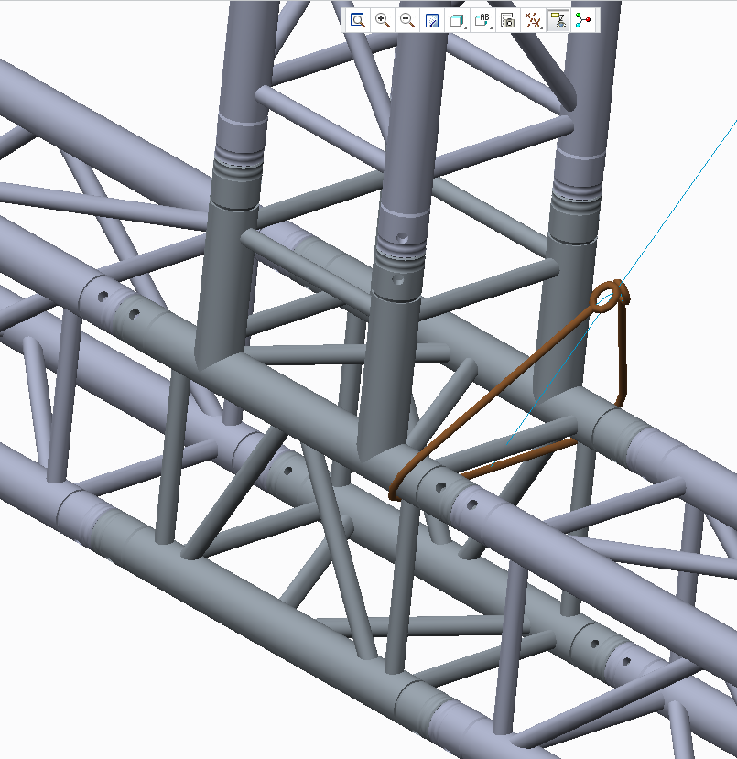 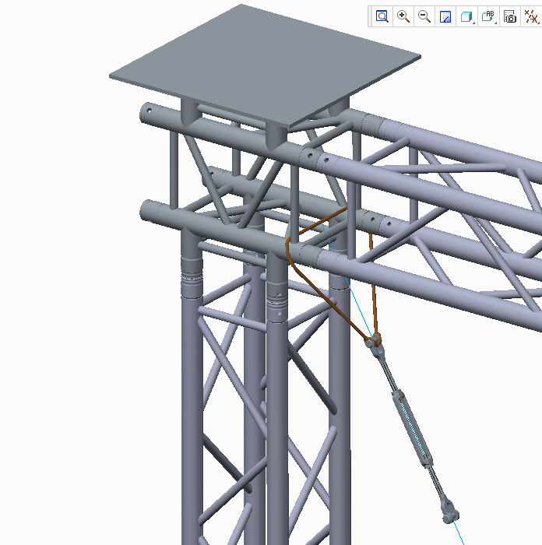

If the uprights and cross members are not fully assembled, secure the lower end of the full cross ropes to the lower anchor loop via a shackle. Attach a float to the top end.

After the uprights and cross members are full assembled attach the upper end of the cross ropes to the turnbuckles and tighten evenly till both ropes are snug. If feasible take a measurement of each cross length to ensure the uprights are perpendicular.

## Routing of Control Lines

**Starboard side**

Tie with a bowline or shackle end of line to the end stop. Route to starboard pulley on closest track car. Loop back to pulley on end stop. Route through block on truss member and tie off to handle on truss plate.

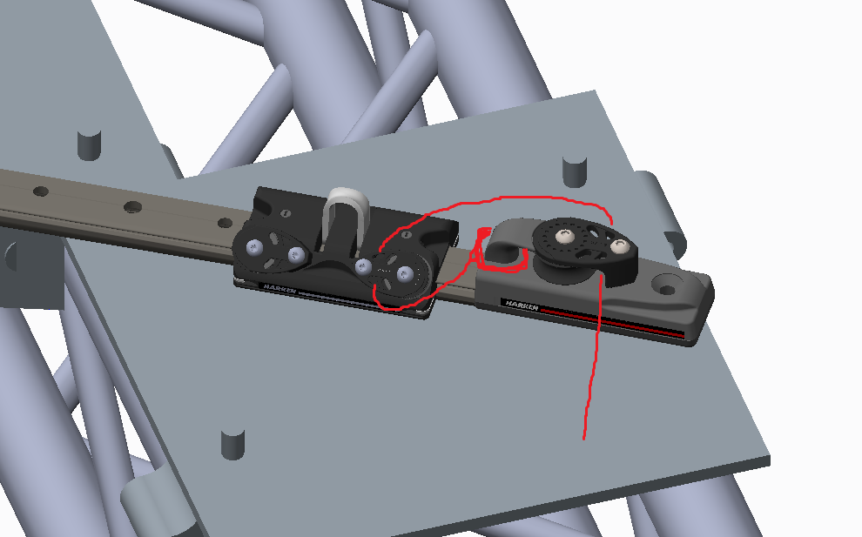

**Port side**

Tie with a bowline or shackle end of line to the end stop. Route to port pulley on nearest track car. Loop back to pulley on end stop. Route through block on truss member and tie off to handle on truss plate.

**Between the cars**

The design to properly space the cars was intended to utilize a length of the v-100 rope, it is also possible to use a length of rod, channel or some other rigid material to space the cars. The dimension between centers on the cars is 2867 mm. McMaster does not have anything suitable in 10 ft. length.

**Aft Line**

Drill and chamfer ball stop to accept 8mm line.

Locate aft block as shown below, 2500 mm from port rear corner truss joint.



Loop aft line through stop ball, through aft block and tie off to rear port truss plate.

## Mooring lines.

Shackle forward mooring lines to forward cars attach floats at upper end.

Shackle rear line to aft control line eye and attach float to upper end.

## Bolting to carriage

The proper method to bolt the rig assembly to the carriage must be determined in situ.

One method that may work is to determine the proper angle of the port rear clamp. Given this angle we can determine the proper location and orientation of the bolt pattern on the mating truss plate. With this position fixed. We can match drill the other locations as there is good access from the topside.

An alternative method would be to mount the clamps to the carriage take good measurements to each hole location and drill generous clearance holes in all of the truss plates.

## Additional Items

* Red Loctite the end stop bolts to be sure they don’t come loose. Did not have the height for lock washer.
* Position and Lash blocks. (I tied on 2 blocks using the recommended knot, but these should be checked.)
* Check and make sure foam is properly secured under channel.
* Replace wingnuts with regular nuts if concerned.
* There are 8 Clamps with eyebolts and 4 Clamps with nuts that are extras and can be used for extra support, lifting, rigging etc.
* The track alignment wedge is in the box of harken stuff.

## Lifting and positioning.

Once full assembly is ready to for lifting it is critical to distribute the load as evenly as possible. It is highly recommended to use 4 lifting points and a spreader bar to maximize the lift point separation and minimize the reaction angles on the structure.

Lifting CG and weight is in process. I will send recommended pick points with analysis early next week.